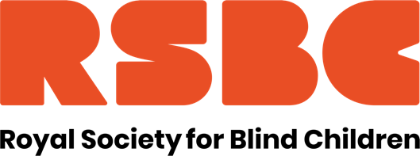

Job Title: Habilitation Specialist
Reports to: Services Director
FTE: 1FTE. Full time, permanent. 37 hours per week.
Location: Hybrid with the possibility of a remote base, but regular attendance at the London Office and within London would be required.
Salary: £42,000 p.a.

RSBC are seeking an experienced Habilitation Specialist to join our Services Directorate. In this varied role you’ll have the opportunity to work with children, young people and families directly, as well as developing and delivering training. You’ll be our organisational expert in all things Habilitation and be part of a wider team seeking to ensure blind and partially sighted children and young people can live their life without limits.

Who are we looking for?
Someone with a nationally recognised qualification in habilitation training for children and young people with a visual impairment. You will have significant experience of working with children and young people with vision impairment and additional needs, excellent written and oral skills, and good IT skills. There will be the occasional weekend and evening work for which time off in lieu will be given

In return we offer a competitive range of benefits including a generous annual leave allowance of 28 days (rising to 29 days after 3 years’ service) + bank holidays, an option to buy an additional 2 days of annual leave, Employee Assistance Programme, Perkbox, flexible working opportunities, 3% contribution towards pension, access to 24/7 GP, mental health care and dental advice via apps if member of pension scheme, season ticket loan. We are a welcoming, diverse and inclusive workforce and are a Disability Confident Employer. We also hold the Investors in People Silver Award.
For further details on the role, please refer to the Job Description and Person Specification.
https://www.rsbc.org.uk/work-for-us/
Please apply by emailing your CV and a supporting statement which details how you meet the requirements of the role and person spec to recruitment@rsbc.org.uk

Closing date: 31 July 2024
Interview: 8 August

To apply you will need to have the right to work in the UK. We do not provide any sponsorship.

The Society is committed to safeguarding and promoting the welfare of children, young people and adults and expects all staff and volunteers to share this commitment. Therefore, all posts are subject to an Enhanced Disclosure check from the Disclosure and Barring Service and 2 satisfactory professional references. Registered Charity No.307892

