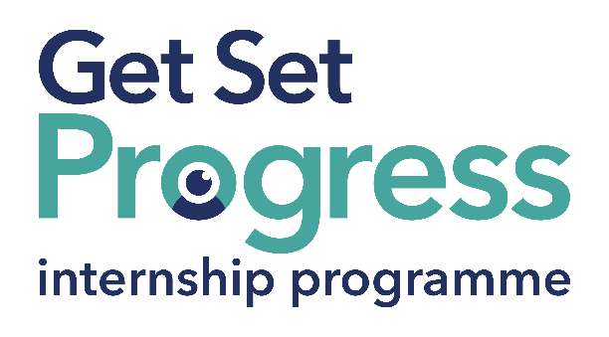 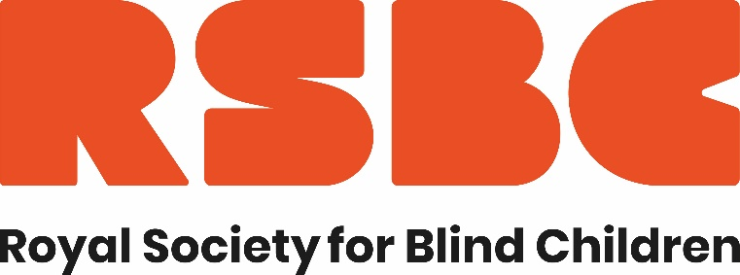

# Learning Support Assistant

## Join us at the Royal Society for Blind Children (RSBC)

Thomas Pocklington Trust (TPT) and RNIB are collaborating with organisations from both the sight loss and wider charity sector as well as corporate organisations to create new opportunities for blind and partially sighted people to find employment through the Get Set Progress (GSP) Internship programme. RSBC is delighted to be offering an internship as part of the Get Set Progress scheme.

Are you interested in working for an organisation making a real difference to the lives of young blind and partially sighted people? Here at the Royal Society for Blind Children we believe that every blind young person should have the chance to live life without limits. RSBC Dorton College is an independent specialist college in the London Borough of Bromley. We offer a day provision for vision impaired 16-25-year-olds and many of our students have additional needs.

## Our Values

Our values of Trust, Energy, Ambition, and Motivation underpin everything we do, and by giving young people the essential skills to take control of their life, they can unleash their true potential.

## What are the benefits of a Get Set Progress internship for me?

As part of your 9-month internship, you will be part of a large cohort of fellow interns and gain the following:

* Obtain valuable work experience within the charity sector
* Technology support (Including Microsoft Office) and upskilling opportunities
* Online and in-person Training and development opportunities
* Opportunity to present and network with Senior leaders within the Sight Loss Sector
* Opportunities to build relationships with fellow interns
* A personal mentor offering support, advice and guidance throughout your internship
* Help deliver positive changes for people with sight loss

Blue and Teal coloured Works for Me logo featuring a graphic of an eye within the O in 'works'. with employment programme written in smaller letters underneath in dark blue. 


As part of the GSP Internship programme, you will also be enrolled on the TPT **Works For Me** Employment Programme, where you will gain bespoke employment support, guidance and advice from the TPT Employment Team, some of the skills that you will receive support and guidance around include:

* CV writing
* Job searching
* Cover letter and speculative letter writing
* Application form writing
* Interview techniques

Job description

Role: Learning Support Assistant

Department: RSBC Dorton College

Reporting to: College Principal and Education Director

Location: RSBC Dorton College, Orpington College Campus, The Walnuts, High Street, Orpington BR6 0TE

Salary: Based on the [Real Living Wage](https://livingwage.org.uk/)

Contract type: Fixed Term, 9 months Full time – 35 hours a week

## Job Specification Information

**Job purpose: Overview of the role:**

To work as part of a dedicated and enthusiastic team, to support students from a range of different backgrounds with vision impairment, to effectively access their courses within one of our mainstream partnership colleges or from the college hub. To promote the students' independence in learning and skills. To work alongside and in liaison with a range of college specialists and professionals, to ensure that the students’ experience is rich, varied, and contributes to developing independence and well-being.

**Key areas of responsibility:**

* Support the delivery of learning programmes delivered at one of our partnership colleges, or from the student hub on study days.
* Produce adapted classroom resources, providing classroom support or supported study, for a range of courses.
* Support the students to fully participate in a range of learning and leisure activities.
* Track and record student progress and achievement within set timeframes.
* Have a clear understanding of individual student needs, including mobility, learning, adaptive, medical, or behavioural strategies, to promote independence and enable students to manage and take increased responsibility for their own learning and behaviour.
* Use ICT and other technologies to adapt classroom resources in students’ preferred mediums.

**Personal specification - Essential criteria:**This post has a Genuine Occupational Requirement that the successful applicant be a person who is blind or partially sighted, in line with The Equality Act 2010

* Ability to think creatively and problem-solve.
* Ability to use basic ICT software, particularly Word, and Outlook.
* Awareness and understanding of Equality and Diversity.
* Knowledge of how the support role promotes independent learning and personal development.
* Ability to work under own initiative and as part of a wider team.
* Understanding and awareness of individual needs and ability to adapt resources to meet the students’ needs. i.e. large text
* Motivation to participate in ongoing training and self-directed CPD programmes.
* Flexibility and ability to work with students, following a range of programmes at different levels
* Willingness to travel to the TPT Hub in London for intern development events throughout the course of the internship programme (costs covered by TPT).
* Having **not** previously undertaken the Get Set Progress internship programme.

## What to do next

Please send your completed application to recruitment@rsbc.org.uk

## **Closing date**

7th August 2024 17:00

## About RSBC

We are a disability confident employer.