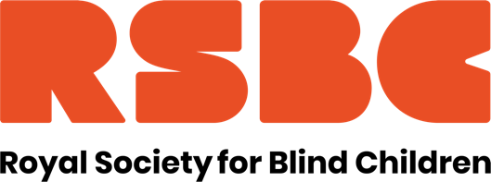

Job Title: Tutor of functional skills and supported study
Reports to: College Leadership Team
FTE: 35 hours per week. Term time + 1 week. Fixed term until Summer 2025.
Location: Orpington
Salary: £35,000 p.a. (£41,826 FTE)

Are you interested in working for an organisation making a real difference to the lives of young blind and partially sighted people?
Here at the Royal Society for Blind Children we believe that every blind young person should have the chance to live life without limits. Our values of Trust, Energy, Ambition, and Motivation underpin everything we do, and by giving young people the essential skills to take control of their life, they can unleash their true potential.

We are looking for a Tutor to plan, prepare and deliver supported study sessions for students in a range of key areas including English, Maths and accredited learning as well as preparing supported study sessions for a team of LSAs.

Some of the key tasks for the Tutor role include:
- Supervising student progress against individual EHCP targets and outcomes
- Working closely with the college leadership team to provide input towards the curriculum and act as a point of contact for tutors at partnership colleges
- Liaise with partnership colleges around homework and extended learning and coordinate the delivery of these on student hub days
- Keep appropriate records in line with college requirements
- Liaise with the wider multi-disciplinary team to agree and provide appropriate support, strategies and adjustments required by students

In return we offer a competitive range of benefits including Perkbox, 3% contribution towards pension, access to 24/7 GP, mental health care and dental advice via apps if member of pension scheme, Employee Assistance, season ticket loan. We are a welcoming, diverse and inclusive workforce and are a Disability Confident Employer. We also hold the Investors in People Silver Award.

For further details on the role, please refer to the Job Description and Person Specification.

https://www.rsbc.org.uk/work-for-us/

Please apply by emailing your CV and a supporting statement which details how you meet the requirements of the role and person spec to recruitment@rsbc.org.uk

Closing date: Please apply asap. Applications will close on 27 Jan.
Interview: from the end of Jan

To apply you will need to have the right to work in the UK. We do not provide any sponsorship.

The Society is committed to safeguarding and promoting the welfare of children, young people and adults and expects all staff and volunteers to share this commitment. Therefore, all posts are subject to an Enhanced Disclosure check from the Disclosure and Barring Service and 2 satisfactory professional references. Registered Charity No.307892

